2a.SORT AN ARRAY OF DATA IN ASCENDING ORDER

AIM:
To write an assembly language program to sort an array of data in ascending order. The array is stored in memory starting from 4200H. The first element of the array gives the count value for the number of elements in the array.

APPARATUS REQUIRED:
- 8085 microprocessor kit 1
- Power card 1
- Keyboard 1

ALGORITHM:
- Load the count value from memory to A-register and save it in B-register
- Decrement B-register (B is a count for (N-1) repetitions)
- Set HL pair as data address pointer
- Set C-register as counter for (N-1) comparisons.
- Load a data of the array in accumulator using the data address pointer
- Increment the HL pair (data address pointer)
- Compare the data pointed by HL wait accumulator
- If carry flag is set (If the content of accumulator is smaller than memory) then go to step 10, otherwise go to next step
- Exchange the content of memory pointed by HL and the accumulator
- Decrement C-register. If zero flag is reset go to step 6 otherwise go to next step
- Decrement B-register. If zero flag is reset go the step 3 otherwise go to next step
- Stop.

Output:

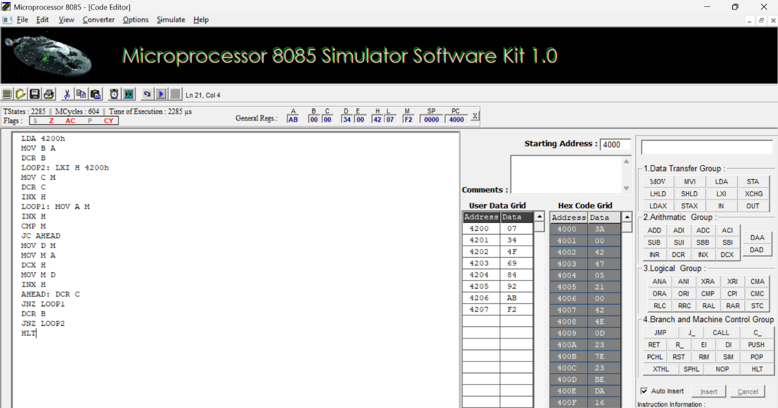

RESULT:
Thus, an assembly language program for sorting in Ascending order of an unsorted array of given 8-bit numbers was written, executed and Verified the Result successfully using 8085 kit.

